服了这个实验的验证：结果是可以实现无状态自动配置。
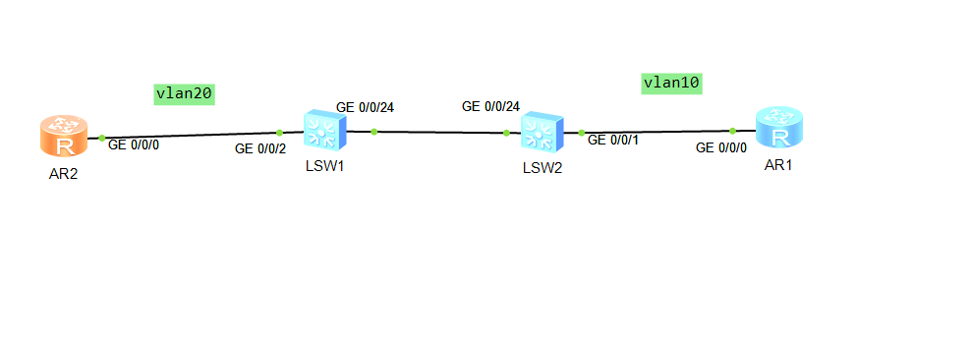
两台sw
vlan 10 //创建vlan 2
vlan 20 //创建vlan 3
interface g0/0/24 //进入端口e5
port link-type trunk //类型设为trunk
port trunk allow-pass vlan 10 20 //将trunk类型的端口加入vlan 10 和 vlan 20

sw1：
<Huawei>sys
Enter system view, return user view with Ctrl+Z.
[Huawei]sys sw1
[sw1]un in en
Info: Information center is disabled.
[sw1]vlan 10
[sw1-vlan10]vlan 20
[sw1-vlan20]interface g0/0/24
[sw1-GigabitEthernet0/0/24]port link-type trunk
[sw1-GigabitEthernet0/0/24]port trunk allow-pass vlan 10 20
[sw1-GigabitEthernet0/0/24]q
[sw1]ipv6
[sw1]int g0/0/2
[sw1-GigabitEthernet0/0/2]port link-type access
[sw1-GigabitEthernet0/0/2]port default vlan 20
[sw1-GigabitEthernet0/0/2]int vlan 10
[sw1-Vlanif10]ipv6 en
[sw1-Vlanif10]ipv6 address 2021::1:2 64
[sw1-Vlanif10]undo ipv6 nd ra halt
[sw1-Vlanif10]un ipv6 address 2021::1:2 64
[sw1-Vlanif10]ipv6 address 2021::1:1 64
[sw1-Vlanif10]int v 20
[sw1-Vlanif20]ipv6 en
[sw1-Vlanif20]ipv6 address 2022::1:1 64

Sw2：
<Huawei>sys
Enter system view, return user view with Ctrl+Z.
[Huawei]sys sw2
[sw2]un in en
Info: Information center is disabled.
[sw2]vlan 10
[sw2-vlan10]vlan 20
[sw2-vlan20]interface g0/0/24
[sw2-GigabitEthernet0/0/24]port link-type trunk
[sw2-GigabitEthernet0/0/24]port trunk allow-pass vlan 10 20
[sw2-GigabitEthernet0/0/24]int g0/0/1
[sw2-GigabitEthernet0/0/1]port link-type access
[sw2-GigabitEthernet0/0/1]port default vlan 10
[sw2-GigabitEthernet0/0/1]int vlan 20
[sw2-Vlanif20]ipv6 en
Info: Please enable IPv6 function in system view.
[sw2-Vlanif20]ipv6 address 2022::1:2 64
Info: Please enable IPv6 function in system view.
[sw2-Vlanif20]int vlan 10
[sw2-Vlanif10]ipv6 en
Info: Please enable IPv6 function in system view.
[sw2-Vlanif10]q
[sw2]ipv6
[sw2]int vlan 20
[sw2-Vlanif20]
[sw2-Vlanif20]undo ipv6 nd ra halt

r1和r2同时这么配置
ipv
int g0/0/0
ipv6 en
ipv6 address auto link-local //开启链路本地单播地址单播获取
ipv6 address auto global default //设置接口的ipv6地址配置方式为global(无状态获取)
dis ipv6 int g0/0/0 //查看有没有自动配置成功

